

Software Engineering Department

Braude College

**Capstone Project Phase A – 61998**

GradeUp: Interactive Learning and Teaching Platform

(24-2-D-35)

[Dr. Natali Levi](mailto:NatalyL@braude.ac.il)

Shokry Arraf: [arraf.shokry.as@gmail.com](mailto:arraf.shokry.as@gmail.com)

Amran Zoabi: [amran.zoabi@e.braude.ac.il](mailto:amran.zoabi@e.braude.ac.il)

Abstract

GradeUp Interactive Learning and Teaching Platform is designed to address the multifaceted challenges faced by traditional classroom education, especially for younger students and those with Attention Deficit Hyperactivity Disorder (ADHD). This innovative project aims to create a comprehensive educational software application from the ground up, integrating cloud technology and gamification to enhance the learning experience. The platform tackles issues such as maintaining student engagement, catering to diverse learning styles, and efficiently managing educational content, particularly during emergency situations like conflicts or natural disasters. GradeUp offers a variety of features including interactive learning modules, real-time progress tracking, and gamified elements such as badges and rewards to keep students motivated. It also provides educators with customizable lesson plans and collaborative tools to facilitate group projects and discussions. Additionally, the platform includes emergency alerts and safety protocols to ensure student safety and continuous learning during disruptions. By leveraging modern technology, GradeUp seeks to improve educational outcomes for all students, enhance the teaching capabilities of educators, and provide a robust solution for the unique challenges presented in today's educational landscape.

-**Keywords** : Interactive Learning, Personalized Learning, Gamification, Attention Deficit Hyperactivity Disorder (ADHD), Emergency Situations.

1. **Introduction**

Traditional classroom education, particularly for students in lower grades, often faces significant challenges in maintaining student engagement and catering to diverse learning styles [‎1]. In today’s rapidly evolving educational landscape, these challenges are further exacerbated by the increasing diversity in student needs, particularly among those with learning disabilities such as ADHD [‎2]. Additionally, during emergency situations, such as conflicts or natural disasters, the traditional learning environment is often disrupted, forcing students to adapt to less structured, more independent learning scenarios [‎3]. In such cases, maintaining student focus and engagement becomes even more difficult, and the role of teachers in managing and delivering educational content effectively becomes significantly more complex [‎4].

The educational field is witnessing a growing demand for innovative methods that not only make learning more interactive but also enhance student motivation and retention [5]. The absence of integrated platforms that combine educational content management with engaging, gamified experiences and mobile accessibility has made it challenging for educators to provide a cohesive and engaging learning experience, especially during crises [‎6]. In emergency situations, where the continuity of education is paramount, these challenges are amplified, often leading to gaps in learning and reduced educational outcomes [‎7].

To address these pressing issues, the GradeUp Interactive Learning and Teaching Platform is proposed. This project aims to develop a robust software application that leverages cloud technology, gamification, and real-time analytics to transform traditional educational methods into a more dynamic and responsive system [‎8]. The platform is designed to accommodate a wide range of learning styles and needs, ensuring that every student can stay engaged and motivated, even during challenging times [‎9].

GradeUp offers interactive learning modules that cater to different learning preferences, helping students remain focused and enthusiastic about their studies. The platform’s real-time progress tracking feature allows educators to monitor student performance closely and provide immediate feedback, which is particularly crucial for maintaining the momentum of learning during periods of disruption [10]. This continuous assessment and feedback loop helps mitigate the negative impacts of interrupted education, ensuring that students remain on track despite external challenges.

Furthermore, GradeUp incorporates gamified elements, such as badges, rewards, and leaderboards, to foster a sense of achievement and competition among students. These features not only make learning more enjoyable but also help sustain student interest and motivation, particularly in situations where traditional classroom dynamics are absent [‎8]. The platform’s gamification strategy is designed to create an engaging and supportive learning environment that encourages students to take an active role in their education.

For educators, GradeUp provides a suite of powerful tools to create, customize, and manage lesson plans, making it easier to implement targeted and effective teaching strategies. The platform also supports collaborative features, enabling group projects and discussions that are vital for developing social and cognitive skills, even in a virtual learning environment [‎6]. This flexibility allows teachers to adapt their instructional methods to the needs of their students, whether they are teaching in a traditional classroom setting or during a crisis.

In addition to its educational features, GradeUp is equipped with emergency alerts and safety protocols to ensure continuous learning during disruptions [7]. These features make GradeUp particularly effective in scenarios like wars or strikes, where maintaining the educational process is challenging. By providing a stable and reliable platform for learning, even in the most difficult circumstances, GradeUp aims to ensure that education remains accessible and effective for all students.

By leveraging cutting-edge technology, GradeUp seeks to revolutionize education by improving learning outcomes for students, enhancing teaching capabilities, and providing a robust solution to the unique challenges presented by today’s educational landscape [‎3].

### Background

### This section provides a comprehensive overview of the challenges traditional classroom education faces during emergency situations, such as wars, pandemics, or natural disasters. These emergencies can disrupt the learning environment, leaving students struggling to stay engaged and maintain their academic progress. In addition, children with ADHD for instance are more vulnerable in such circumstances, as the lack of structure and increased stress can exacerbate their difficulties in focusing and learning. This background will also explore relevant educational tools designed to support students in these scenarios, highlighting the need for innovative solutions like GradeUp to ensure continuity in education for all students.

### 2.1 Traditional Classroom Education and Its Challenges

### Traditional classroom education has been the cornerstone of learning for centuries. However, it often struggles to cater to diverse learning styles and maintain student engagement, particularly in the lower grades. The conventional methods can be particularly challenging during emergency situations like wars, where the stability and continuity of education are severely disrupted.

### 2.1.1 Historical Context

### The roots of traditional classroom education can be traced back to ancient civilizations, where formal education was primarily the privilege of the elite. Over time, public education systems were developed to provide structured learning to the masses. The industrial revolution further solidified the model of standardized, one-size-fits-all education, emphasizing uniformity and discipline.

### 2.1.2 Current Challenges

### In the contemporary educational landscape, the one-size-fits-all approach is increasingly seen as inadequate. Traditional classroom education faces several significant challenges. Maintaining student engagement is a primary issue, as many students struggle to stay attentive and participate actively with conventional teaching methods [11]. Additionally, catering to diverse learning styles is difficult since students have varied preferences and paces, making it challenging for educators to address everyone’s needs with a single approach [‎12].

### Emergency situations such as wars, natural disasters, or pandemics can severely disrupt the continuity of education, leaving students without access to proper learning resources [‎13]. Furthermore, children with conditions like Attention Deficit Hyperactivity Disorder (ADHD) often find it particularly difficult to stay focused and engaged with standard teaching methods, requiring more personalized and interactive approaches [‎14].

### Teachers are often overwhelmed by the dual task of delivering educational content and tracking student progress in real-time. The lack of integrated platforms that combine educational content management, gamified learning experiences, and mobile accessibility limits the creation of dynamic and engaging learning environments. Additionally, keeping students motivated and ensuring knowledge retention is a constant struggle, especially when learning experiences are not interactive or enjoyable.

### Traditional methods also often lack efficient tools for tracking and analyzing student progress, making it difficult to provide timely and tailored support. Limited access to updated and diverse educational resources further hinders the quality of education and the ability to address different learning needs effectively.

### These challenges underscore the need for innovative educational solutions that leverage modern technology to create a more engaging, personalized, and resilient learning environment.

### 2.3 Commonly Used Educational Tools and Terms

### To address the diverse needs of students, including those with ADHD, various educational tools and approaches have been developed.

### 2.3.1 Gamification

### Gamification involves incorporating game-like elements into non-game contexts to enhance engagement and motivation. This approach has been shown to be effective in educational settings, where elements such as points, badges, and leaderboards can make learning more interactive and enjoyable [16].

### 2.3.2 Personalized Learning

### Personalized learning tailors educational experiences to individual students' needs, strengths, and interests. This approach often involves adaptive learning technologies that adjust the difficulty and type of content based on real-time assessments of a student's performance [‎17].

### 2.4 Noteworthy Educational Platforms

### The increasing accessibility of technology has significantly enhanced the development and use of applications designed to address various educational challenges, particularly in emergency situations like wars, natural disasters, and pandemics. These emergencies can disrupt traditional education, making it essential to explore innovative digital solutions that ensure continuity in learning.

### One notable example is Khan Academy, a nonprofit educational organization that offers free online courses, lessons, and practice exercises. During times of crisis, Khan Academy's adaptive learning technologies provide a lifeline for students by offering personalized learning experiences even when schools are closed. The platform's data-driven approach helps educators remotely identify students' strengths and areas for improvement, enabling targeted interventions. Research indicates that students using Khan Academy during emergencies can maintain academic performance despite disruptions to their traditional learning environments [‎15].

### ClassDojo is another platform that has proven valuable in maintaining educational engagement during emergencies. Originally designed as a classroom management tool, ClassDojo facilitates communication between teachers, students, and parents. During crises, this communication is crucial, as it allows teachers to share updates, assignments, and support materials. The platform's use of gamification, such as points and badges, helps maintain student motivation and engagement when regular classroom interactions are not possible [16].

### Google Classroom is widely used in emergency education settings due to its simplicity and accessibility. In situations like the COVID-19 pandemic, Google Classroom allowed teachers to quickly shift to remote teaching, providing a centralized platform for assignments, feedback, and communication. Its integration with other Google services, such as Google Meet and Google Drive, made it an effective tool for maintaining a structured learning environment during periods of disruption [‎17].

### Edmodo is another platform that has been employed to support education in emergency settings. Edmodo provides a social learning environment where teachers can create virtual classrooms, share resources, and engage students through online discussions. This has been particularly useful during conflicts and natural disasters, where traditional classroom settings are unavailable. Edmodo's focus on community and collaboration helps keep students connected and engaged, even in challenging circumstances [‎18].

### Seesaw is another innovative platform that enhances student engagement through interactive learning. Seesaw allows students to create, share, and reflect on their work through a digital portfolio. Teachers can provide real-time feedback, and parents can stay informed about their child's progress. The platform's interactive features and user-friendly interface have been shown to increase student engagement and parental involvement [‎20].

### In the realm of addressing ADHD in educational settings, researchers have explored various digital interventions. For example, a study conducted by Bul et al. (2016) [‎21]developed a game-based digital therapeutic for children with ADHD. This therapeutic uses adaptive algorithms to present cognitive challenges tailored to the child's performance, demonstrating significant improvements in attention and inhibitory control. The gamified nature of the intervention helps maintain student engagement and motivation.

### Rumie offers an innovative solution for the educational needs of students during emergencies. Rumie provides access to offline educational content through its low-cost, easy-to-use tablets, which have been deployed in conflict zones and refugee camps. By offering preloaded educational resources, Rumie ensures that learning can continue even in the absence of internet connectivity, making it a valuable tool in crisis situations [‎19].

### Overall, these technological advancements underscore the importance of integrating digital solutions into educational practices, especially during emergencies. The development of platforms like GradeUp, which combines cloud technology and gamification, represents a significant step forward in creating effective and accessible educational tools that can adapt to the unique challenges of emergency situations. By leveraging these technologies, educators can ensure that learning continues uninterrupted, providing critical support to students during times of crisis.

### Expected Achievements

We aim to achieve the following concrete and precise outcomes:

#### 3.1. **Outcomes**

### The primary goal of this project is to develop GradeUp, a comprehensive educational platform designed to enhance the learning experience for students in general, with a particular focus on those facing challenges, such as students with ADHD and those in emergency situations like wars or natural disasters. The platform is intended to provide an engaging, interactive, and effective tool for both educators and students, with the following specific objectives:

### Enhanced Learning Experience:

### Measurement: Conduct student surveys and assessments to evaluate engagement levels and learning outcomes compared to traditional methods. We expect an increase in student engagement and academic performance by at least 20%.

### Details: The platform will offer personalized learning experiences tailored to individual student needs, making learning more enjoyable and effective.

### Real-Time Progress Tracking:

### Measurement: Implement analytics and reporting tools to track student progress and provide educators with real-time data. Success will be measured by the accuracy and usefulness of the data in aiding educators to identify student needs and adjust teaching strategies.

### Details: GradeUp will include features that allow educators to monitor and assess student progress continuously, helping them identify areas where students may need additional support.

### Interactive and Engaging Learning Modules:

### Measurement: Monitor usage statistics and feedback on interactive modules to ensure they are being used effectively and enhancing the learning experience. We expect at least 80% of students to find these modules beneficial.

### Details: The platform will incorporate gamified elements such as quizzes, badges, and rewards to maintain student motivation and make learning more enjoyable.

### Ease of Use for Educators:

### Measurement: Gather feedback from educators on the usability of the platform, aiming for at least 85% of educators to report that GradeUp simplifies lesson planning, teaching, and progress tracking.

### Details: GradeUp will be designed to reduce the administrative burden on educators, providing intuitive tools for lesson planning, student assessment, and communication with parents.

### Scalable, Secure, and Accessible Solutions:

### Measurement: Test the platform's performance under different conditions and ensure compliance with security standards. Success will be determined by the platform's ability to handle large numbers of users without compromising security or performance.

### Details: The platform will be built using modern, scalable technologies to ensure it can accommodate a growing number of users while maintaining security and accessibility.

### Collaboration and Social Skills Enhancement

### Group Projects and Discussions:

### Implementing virtual classrooms, shared documents, whiteboards, and video conferencing tools for real-time collaboration.

### Creating discussion forums for topic-based conversations, resource sharing, and peer feedback.

### Facilitating peer feedback mechanisms to encourage constructive criticism and support among students.

### Emergency Preparedness and Continuity of Learning:

### Measurement: Evaluate the platform's effectiveness during simulated emergency situations, such as network outages or school closures. Success will be measured by the platform’s ability to maintain continuous learning with minimal disruption.

### Details: GradeUp will feature offline learning modules and downloadable content to ensure students can continue learning during emergencies. The platform will also provide educators with tools to quickly adapt lesson plans and communicate with students and parents during crises.

### By achieving these outcomes, GradeUp will not only enhance the teaching and learning experience but also provide a robust solution for the unique challenges presented in today’s educational landscape, particularly in times of crisis.

### 4. Success Criteria

### The success of the project will be measured based on the following criteria:

### User Engagement and Satisfaction:

### High levels of engagement from students and educators, indicated by usage metrics and positive feedback.

### Improvement in Academic Performance:

### Demonstrable improvements in academic performance and task completion rates among users of the platform.

### Effective Personalization:

### Successful implementation of personalized learning paths that adapt to individual student needs, showing positive learning outcomes.

### Enhanced Social Interactions:

### Increased participation in group projects and discussions, leading to improved social skills and collaboration among students.

### System Stability and Security:

### A robust and secure cloud infrastructure with minimal downtime and compliance with data protection standards.

### Positive Feedback from Educators:

### Positive feedback from educators regarding the effectiveness of the platform's analytics tools and their ability to provide targeted support to students.

**5. The Process**

*5.1 Research – Traditional Classroom Education and Technology Integration*

To develop the GradeUp educational platform, we conducted extensive research into the challenges of traditional classroom education, especially for students in low grades, ADHD students and those affected by emergencies. The research focused on:

* **Understanding Challenges**: Investigating how traditional educational methods fall short in engaging students, particularly in emergency situations or for those with Attention Deficit Hyperactivity Disorder (ADHD). We examined common difficulties in maintaining student engagement and catering to diverse learning styles.
* **Current Educational Tools**: Evaluating existing educational tools and technologies designed to enhance student engagement and learning, and assessing their effectiveness in addressing diverse needs.
* **Gaps and Opportunities**: Identifying gaps in current educational tools and platforms that could be addressed through innovative solutions like GradeUp.

We reviewed academic literature, educational technology reports, and case studies. Insights from educators and experts were integrated to define the essential features for our platform.

*5.2 Constraints and Challenges*

**Technical Constraints**

* **Scalability**: Ensuring the platform can accommodate a growing number of users without performance issues.
* **Security**: Protecting sensitive data and complying with regulations such as GDPR and FERPA.
* **Usability**: Creating an interface that meets the diverse needs of users, including those with ADHD.

**Financial Constraints**

* **Development Costs**: High costs for advanced features and ongoing maintenance.
* **Support Funding**: Ensuring long-term financial support for updates and user assistance.

**Regulatory Constraints**

* **Data Privacy**: Compliance with GDPR, FERPA, and similar regulations.
* **Educational Standards**: Meeting educational guidelines and accreditation requirements.

**Practical Constraints**

* **User Testing**: Limited access to diverse user groups for comprehensive feedback.
* **Resource Management**: Effective allocation of time, personnel, and technology.

**Implementation Constraints**

* **Technological Changes**: Adapting to rapid tech advancements while maintaining stability.
* **User Training**: Providing effective training and support for users.
* **Customization Limits**: Balancing personalization with ease of use.

*5.4 Methodology and Development Process*

As of now, we are in the preparatory phase of the GradeUp project and have not yet begun implementation. Currently, our efforts are concentrated on compiling a comprehensive book that will serve as a foundational document for the project. This book will outline the research, design principles, and planned features for the platform.

Our methodology includes:

1. *Initial Setup:*
   * Defining project scope and objectives.
   * Establishing a framework for the development process.
2. *Design Phase:*
   * Designing the UI/UX with insights from educators and students.
   * Creating wireframes and prototypes based on research findings.
3. *Development Phase (Planned):*
   * **Frontend Development**: Building the user interface and interactive elements.
   * **Backend Development**: Implementing microservices architecture and integrating cloud services.
   * **Gamification Features**: Developing systems for badges, leaderboards, and rewards.
   * **Adaptive Learning Algorithms**: Creating algorithms to personalize learning paths.
4. *Testing and Evaluation (Planned):*
   * Conducting usability testing to refine the design.
   * Running a beta testing phase to gather feedback and make adjustments.
   * Ensuring the platform meets performance, security, and scalability requirements.
5. *Deployment and Monitoring (Planned):*
   * Deploying the platform to the cloud for accessibility.
   * Monitoring performance and user feedback to make ongoing improvements.

*5.3.1 Iterative Development and Feedback*

Once implementation begins, we will adopt an Agile methodology, conducting regular sprint reviews and retrospectives to evaluate progress and address issues. User feedback will be integral to refining the platform and ensuring it meets the needs of its users.

*5.3.2 Continuous Improvement*

Post-launch, we plan to continuously gather user feedback and performance data to make iterative improvements. Our goal is to maintain a dynamic and responsive platform that evolves based on user needs and technological advancements.

**6. Product**

* *Functional Requirements*

|  |  |  |
| --- | --- | --- |
| ID | Requirement | Description |
| FR1 | User Authentication and Authorization | Secure login with different access levels for students, educators. |
| FR2 | Personalized Learning Paths | Adaptive algorithms to tailor learning experiences to individual students. |
| FR3 | Gamification Features | |  | | --- | | Badges, leaderboards, and rewards to motivate students. |  |  | | --- | |  | |
| FR4 | Interactive Learning Modules | |  | | --- | | Multimedia content, real-time feedback, and interactive quizzes. |  |  | | --- | |  | |
| FR5 | Progress Tracking and Analytics | |  | | --- | | Dashboards for performance monitoring and advanced analytics for educators. |  |  | | --- | |  | |
| FR6 | Collaboration Tools | |  | | --- | | Virtual classrooms, shared documents, whiteboards, and discussion forums. |  |  | | --- | |  | |
| FR7 | Content Management | |  | | --- | | Tools for educators to create and manage content. |  |  | | --- | |  | |
| FR8 | Mobile Accessibility | Accessible on mobile devices. |
| FR9 | Emergency Alerts and Safety Protocols | Real-time notifications and safety protocols for emergencies, ensuring continued learning or appropriate actions. |
| FR10 | Customizable User Interface | Allow users to personalize the interface for accessibility and user preferences. |
| FR11 | Role-based Content Access | Provides access to content and tools based on user roles (student, teacher). |
| FR12 | Assessment and Grading System | Automated tools for creating, grading, and analyzing assignments and exams. |
| FR13 | Discussion Forum | Allow students and teachers to communicate and collaborate via discussion boards. |
| FR14 | Assignment Submission | Provide students with the ability to upload assignments and receive feedback. |

* *Non-Functional Requirements*

|  |  |  |
| --- | --- | --- |
| ID | Requirements | Description |
| NFR1 | |  | | --- | | Scalability |  |  | | --- | |  | | |  | | --- | | Handle growing user numbers using scalable cloud infrastructure. |  |  | | --- | |  | |
| NFR2 | Security | |  | | --- | | Data protection with encryption, backups, and compliance with privacy regulations. |  |  | | --- | |  | |
| NFR3 | Usability | |  | | --- | | Intuitive interface with customization options. |  |  | | --- | |  | |
| NFR4 | Performance | |  | | --- | | High availability and fast response times. |  |  | | --- | |  | |
| NFR5 | |  | | --- | | Maintainability |  |  | | --- | |  | | |  | | --- | | Modular design for easy updates and maintenance. |  |  | | --- | |  | |
| NFR6 | Accessibility | |  | | --- | | Compliant with accessibility standards for students with disabilities. |  |  | | --- | |  | |
| NFR7 | Reliability | |  | | --- | | Consistent performance and robust error-handling. |  |  | | --- | |  | |
| NFR8 | Compliance | |  | | --- | | Adherence to educational standards and regulations. |  |  | | --- | |  | |
| NFR9 | |  | | --- | | Interoperability |  |  | | --- | |  | | Integrate with other tools and platforms, supporting standard data formats and APIs. |
| NFR10 | Engagement Metrics | Track student engagement and provide insights for educators to adapt teaching methods. |
| NFR11 | Gamified Learning Analytics | Visualize gamification data like leaderboards and badges to motivate students and inform educators. |

*6.1 Algorithms Used*

*6.1.1 Adaptive Learning Algorithms*

* **Personalized Learning Paths**: Each student will get a personalized learning path depending on multiple factors. Firstly, the teachers can review their students and set their **learning rate** and **skill level** on a scale of 1 to 5, which in turn will change their learning path and the type of content being shown to them. 5 being the highest, 1 the lowest.
  + **Learning Rate** represents the rate at which the student is able to learn new things.
  + **Skill Level** represents how skilled and intelligent the student is, and reflects their ability to be able to solve complex problems.

In turn, the subjects and tasks in the quizzes will also have elements that set their pace and difficulty to help integrate them with the students’ attributes. Each subject will have *time of completion*set into 5 different levels in how long the task should be completed, likewise each subject/quiz will have a *skill level* associated with it – meaning the content will only be shown to the student if their skill level is on par with the level associated with it.

The algorithm will keep track of how well a student doing on each subject/quiz - according to the performance model – ,and it will dynamically change the values of the **learning rate** and **skill level** of the student accordingly.

* **Real-Time Feedback Mechanisms**: These algorithms provide instant feedback, enabling dynamic adjustments to learning paths and activities to suit the student's current understanding. After taking a quiz, the algorithm will give detailed feedback on performance in different aspects of the material, giving the student a better understanding in where improvements should be made.

*6.1.2 Gamification Algorithms*

* **Engagement Metrics**: Behavioral analytics are utilized to track and measure student engagement in real-time. The algorithm continuously monitors how students interact with various elements of the platform, such as the frequency and duration of activity, the types of content they engage with most, and the specific gamified elements (e.g., badges, leaderboards, or challenges) they respond to best. The collected data is analyzed to identify patterns and trends in student behavior. For instance, if a particular badge is frequently earned or a certain type of challenge is regularly completed, the system can infer that these elements are highly engaging. Based on this analysis, the algorithm dynamically adjusts the gamification strategies deployed. For example, if a leaderboard is found to be particularly motivating, the system might increase its visibility or introduce new leaderboard-based challenges to further drive engagement.
* **Reward Systems**: The platform leverages reinforcement learning to optimize the distribution of rewards. This involves analyzing the timing, frequency, and type of rewards that are most effective in sustaining student motivation. The algorithm tracks student performance and engagement to identify optimal moments for delivering rewards. For instance, if a student consistently completes a series of challenging tasks, the system might reward them with a badge or bonus points to reinforce positive behavior. Similarly, if a student doesn’t complete enough tasks, they will be shown motivational messages to get them to do more in order to earn more rewards. The reward system is designed to be adaptive, meaning that it can scale the value or difficulty of rewards based on the student's progression. As a student improves, the system may introduce more complex challenges and corresponding rewards, ensuring that the motivational impact is maintained over time.

*6.2 Models Created*

*6.2.1 Student Performance Model*

* **Predictive Analytics**: This model uses historical data on student performance to predict future outcomes. It analyzes patterns such as quiz scores, assignment completion rates, and engagement levels to forecast how a student is likely to perform in upcoming tasks. The model incorporates machine learning algorithms that continuously learn from new data, allowing it to refine its predictions over time. For example, if a student shows a steady improvement in math skills, the model might predict higher performance in future math-related tasks and adjust the learning path accordingly.
* **Progress Tracking**: This component continuously monitors and records student progress across different subjects and tasks. It generates detailed reports that highlight areas where the student is excelling and areas where they may need additional support. The progress tracking system also provides real-time feedback to educators, enabling them to make informed decisions about how to support each student. For instance, if a student is struggling with a particular topic, the system might recommend supplementary materials or one-on-one tutoring sessions.

*6.2.2 Adaptive Difficulty Model*

* **Adaptive Difficulty**: The model dynamically adjusts the difficulty level of educational content based on real-time assessments of a student's capabilities. It analyzes performance data from quizzes, assignments, and other activities to determine the appropriate level of challenge. If a student consistently performs well, the system might increase the difficulty of subsequent tasks to keep them engaged and challenged. Conversely, if a student is struggling, the system can reduce the difficulty or provide additional support to help them catch up. The model also takes into account factors such as the student's learning pace, preferences, and previous experience with similar content, ensuring a highly personalized learning experience.

*6.3 Data Structure*

*6.3.1 User Data*

* **Profiles**: Stores user information, including personal details, learning preferences, and performance history.
* **Performance Metrics**: Records data on quizzes, assignments, and engagement levels, enabling detailed progress tracking.

*6.3.2 Content Data*

* **Educational Modules**: Organized in a hierarchical structure with metadata tagging for easy retrieval. Includes multimedia content like videos, interactive quizzes, and simulations.
* **Gamification Elements**: Stores information on badges, leaderboards, and reward systems, linked to user profiles to track achievements.

*6.3.3 Analytics Data*

* **Engagement Metrics**: Collects data on user interactions with the platform, such as time spent on activities, and content completion rates. This data is used to generate insights into user behavior, helping the platform identify which content and features are most engaging. For example, if a particular type of quiz consistently receives high completion rates, the system might prioritize this content in future recommendations.
* **Adaptive Learning Paths**: The system logs all adjustments made to a student's learning path, including changes in content difficulty, pacing, and the introduction of new learning objectives. This data is used to continuously refine the adaptive learning algorithms and ensure that each student's experience remains personalized and effective. The logs also provide a historical record of how a student's learning path has evolved, enabling educators and administrators to review and analyze the effectiveness of different interventions and strategies.

*6.4 User Interface (UI)*

*6.4.1 Design Principles*

* **Intuitive and Engaging**: The UI is designed to minimize distractions and enhance focus. It uses a clean layout with clear navigation and interactive elements to keep users engaged.

*6.4.2 Key Components*

* **Dashboard**: Central hub where users can access their profiles, track progress, and view upcoming tasks. Features visual progress tracking tools like charts and progress bars.
* **Learning Modules**: Interactive sections where students can access educational content. Includes videos, simulations, and quizzes with immediate feedback mechanisms.
* **Gamification Hub**: Displays badges, leaderboards, and rewards. Encourages students to engage with the platform and track their achievements.
* **Analytics and Reports**: Provides educators with detailed insights into student performance, engagement levels, and learning gaps. Includes customizable reports and real-time analytics dashboards.

*6.4.3 Interaction Elements*

* **Drag-and-Drop Exercises**: Interactive tasks that engage students actively in the learning process.
* **Discussion Forums**: Platforms for topic-based conversations, resource sharing, and peer feedback, enhancing collaborative learning.
* **Virtual Classrooms**: Tools for real-time collaboration, including shared documents, whiteboards, and video conferencing.

*6.5 Planned Future Developments*

* **Mobile Accessibility**: Optimizing the platform for mobile devices to ensure accessibility anytime, anywhere.
* **Expanded Content Library**: Continuously adding new educational modules and gamified elements to keep the platform fresh and engaging.
* **Advanced Analytics**: Implementing more sophisticated analytics tools to provide deeper insights into student behavior and learning outcomes.

***6.6 Architecture***

* **UI Layer**:
* **UI Elements**: This includes all the visible components the user interacts with, such as buttons, text, and images.
* **State Holders**: Manages the UI state (e.g., current screen, user input, loading indicators) and reacts to changes in the data or domain layers.
* **Responsibility**: Displaying data and capturing user inputs.
* **Domain Layer:**
  + Contains the **business logic** and rules of the application.
  + Includes entities, value objects, and domain services.
  + **Responsibility**: Processes data and enforces the core application rules, independent of UI and data sources.
* **Data Layer:**
  + Handles data management, including fetching, caching, and persisting data.
  + Contains repositories, API calls, and database access.
  + **Responsibility**: Interacts with external data sources (e.g., databases, APIs) and provides data to the domain layer.

*The technologies used for the architecture will be* ***Flutter, Dart(Flutter), Firebase*** *and* ***AWS Services****.*

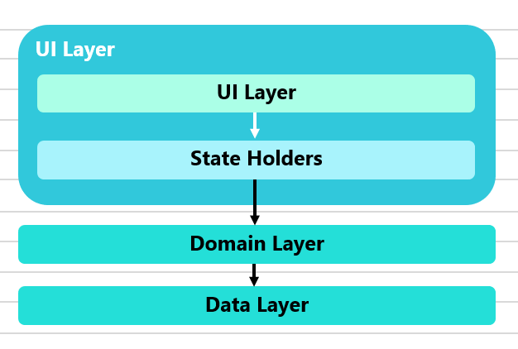

***6.6.2 Package Architecture***

The system is organized into the following key packages:

*a. Student Management Package*

This package handles all the functionalities that are specific to students. It interacts with the other packages to provide a smooth user experience for students.

* **Responsibilities**:
  + Viewing enrolled courses, lectures, videos, and documents.
  + Answering assignments and quizzes.
  + Tracking progress through course material and assignments.
  + Receiving notifications and emergency alerts.
* **Interaction**: This package interacts with the **Notification Package** to receive alerts, the **Assignment Package** for submitting work, and the **Gamification Package** for tracking badges and rewards.

*b. Teacher Management Package*

This package provides the necessary functionalities for teachers.

* **Responsibilities**:
  + Creating and assigning quizzes, homework, and assessments.
  + Tracking student progress and providing feedback.
  + Participating in discussions with students.
  + Receiving notifications and emergency alerts.
* **Interaction**: The package interacts with the **Assignment Package** to manage student submissions, the **Notification Package** to push feedback, and the **Gamification Package** for assigning student rewards.

*c. Assignment Package*

Handles the creation, submission, and review of assignments.

* **Responsibilities**:
  + Teachers create and assign tasks.
  + Students view and complete assignments.
  + Teachers grade and provide feedback on submissions.
* **Interaction**: This package links to both the **Teacher Management** and **Student Management** packages and interacts with the **Notification Package** to alert users when assignments are created or graded.

*d. Notification Package*

Handles sending notifications and alerts to users, including emergency notifications.

* **Responsibilities**:
  + Real-time notifications for assignment creation, submission, and feedback.
  + Emergency alerts pushed to users after login.
  + Discussion or content updates for enrolled students.
* **Interaction**: Integrates with all other packages, particularly with the **Student Management** and **Teacher Management** packages, to notify users of important actions.

*e. Gamification Package*

Handles points, badges, and rewards for student achievements.

* **Responsibilities**:
  + Tracking progress and awarding points and badges based on student performance.
  + Displaying gamification elements on student dashboards.
* **Interaction**: Interacts with both the **Student Management Package** for students earning rewards and the **Teacher Management Package** to allow teachers to view student progress.

***6.6.3 Deployment Architecture***

The system uses a mix of cloud services and cross-platform deployment for maximum scalability and real-time performance.

*a. Frontend*

* **Platform**: The frontend is developed using **Flutter**, which allows deployment across Android, iOS, and the web.
* **Hosting**: The Flutter application is hosted via **Firebase Hosting** or **AWS Amplify**, ensuring seamless updates and continuous deployment.

*b. Backend*

The backend is powered by a combination of **Firebase** for real-time interactions and **AWS** for server-side logic.

* **AWS Lambda**: Serverless functions handle core logic like assignment submission, grading, and notifications. For example, a student submitting an assignment triggers an AWS Lambda function, which processes the submission and stores the data in **Firestore**.
* **Firebase Functions**: Responsible for real-time interactions and notifications, such as sending emergency alerts after a user logs in.
* **Authentication**: **Firebase Authentication** is used to manage secure user logins for both students and teachers.

*c. Database*

* **Firebase**: A NoSQL database is used for storing real-time data such as course materials, assignments, quizzes, and user progress.

*d. Notifications & Alerts*

* **Firebase Cloud Messaging (FCM)**: Handles all notifications, including real-time notifications and emergency alerts, ensuring users are notified of assignments, updates, and emergency situations promptly.

***6.7 Diagrams***

***1-Use Case for GradeUp***

This use case diagram represents the interactions between two primary actors **Student** and **Teacher** within the "GradeUp" educational platform. The diagram outlines various activities that these users can perform and how these activities are interrelated through the system.

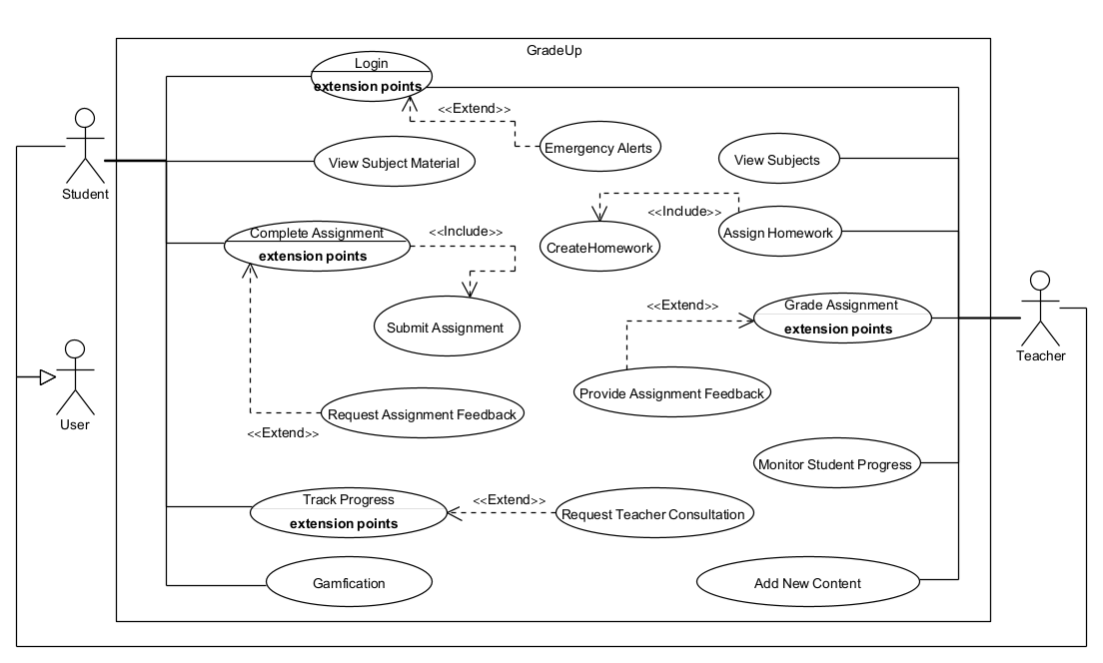

**1. Student Use Cases:**

* **Login:**
  + The Student logs into the system to access their personalized dashboard and educational materials.
* **View Subject Material:**
  + After logging in, the Student can view the subject materials provided by the teacher.
* **Complete Assignment:**
  + The Student works on assignments given by the teacher. This use case has **extension points**, meaning additional actions or steps might be taken during this process.
  + **Extensions:**
    - **Request Assignment Feedback:** The Student can request feedback on their assignment before submission.
* **Submit Assignment:**
  + The Student submits the completed assignment through the platform. This is a critical action that **includes** the preceding step of completing the assignment.
* **Track Progress:**
  + The Student can monitor their progress in the course by viewing grades and feedback provided by the teacher.
  + **Extensions:**
    - **Request Teacher Consultation:** The Student may request a consultation with the teacher to discuss their progress or any difficulties they are facing.
* **Emergency Alert:**
  + After login, the system extends to display emergency alerts, ensuring that if any emergencies are present, they are immediately shown to the user upon successful login.

**2. Educator/Teacher Use Cases:**

* **Login:**
  + Similar to the Student, the Teacher logs into the system to manage courses and interact with students.
* **View Subjects:**
  + The Teacher views the list of subjects they are responsible for.
* **Assign Homework:**
  + The Teacher assigns homework to students based on the subject material. This is an essential part of the educational process and **includes** the creation of the homework assignments.
* **Grade Assignment:**
  + The Teacher grades the assignments submitted by the students. This use case has **extension points** indicating that additional actions may occur during grading.
  + **Extensions:**
    - **Provide Assignment Feedback:** The Teacher provides feedback on the assignments, which is crucial for student improvement.
* **Monitor Student Progress:**
  + The Teacher monitors the academic progress of their students, using data provided by the system to identify areas where students may need additional support.
* **Emergency Alert:**
  + After login, the system extends to display emergency alerts, ensuring that if any emergencies are present, they are immediately shown to the user upon successful login.
* **Add New Content**:
* Teacher can add new content/study material to his students.

***2- Data Flow:***

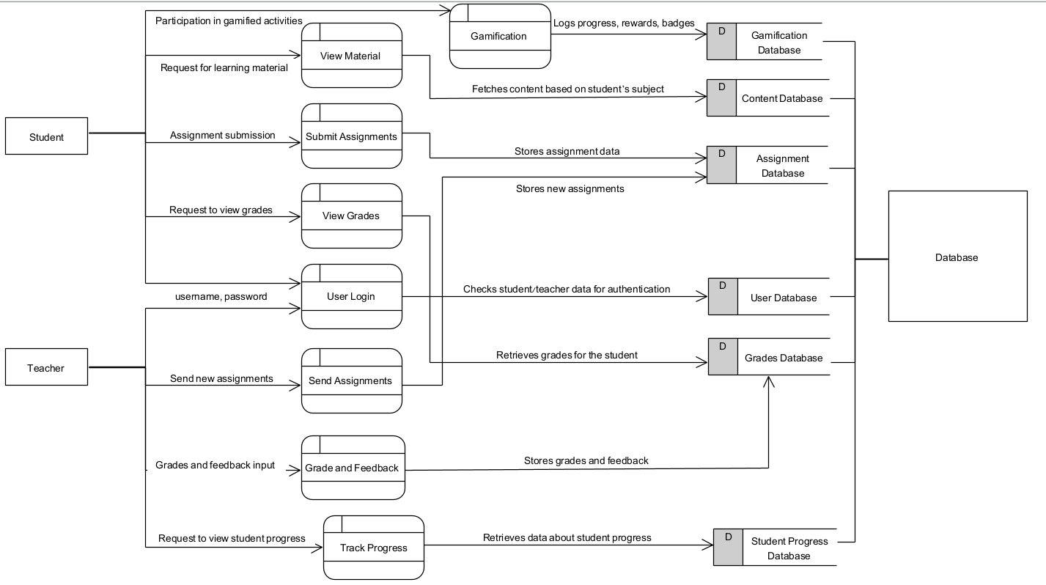

***3-Activity:***

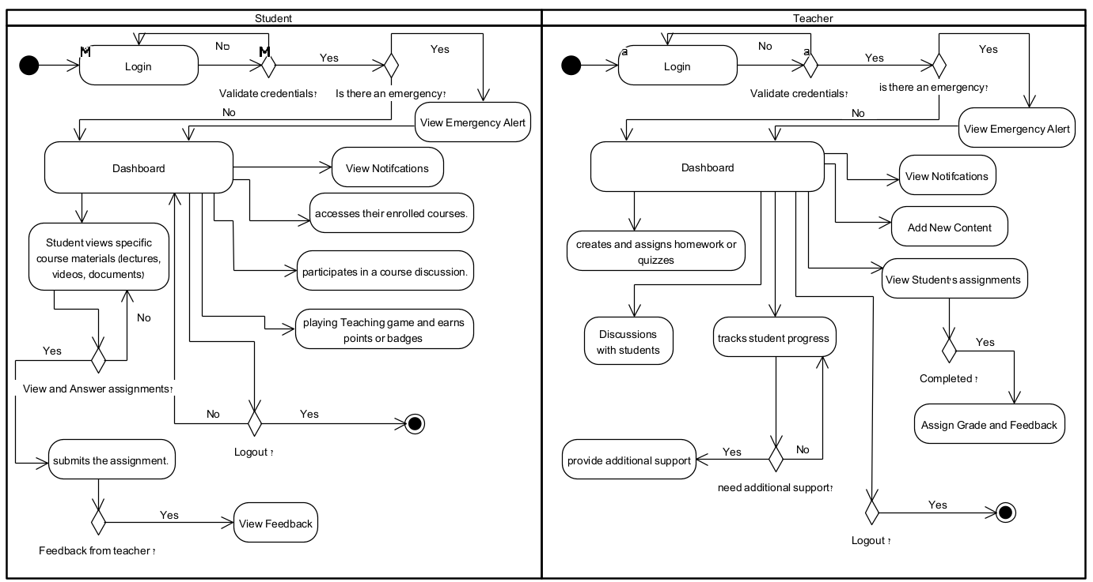

***6.8 - Prototype:***

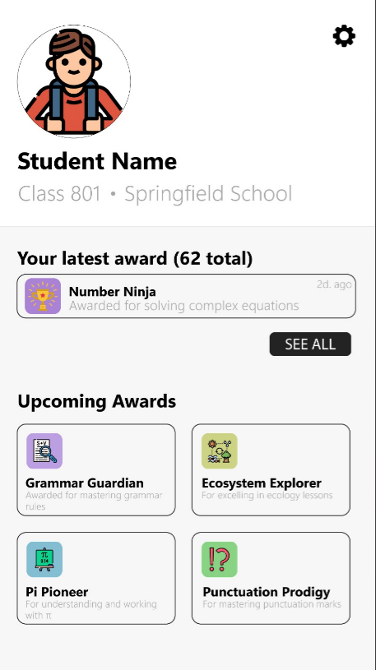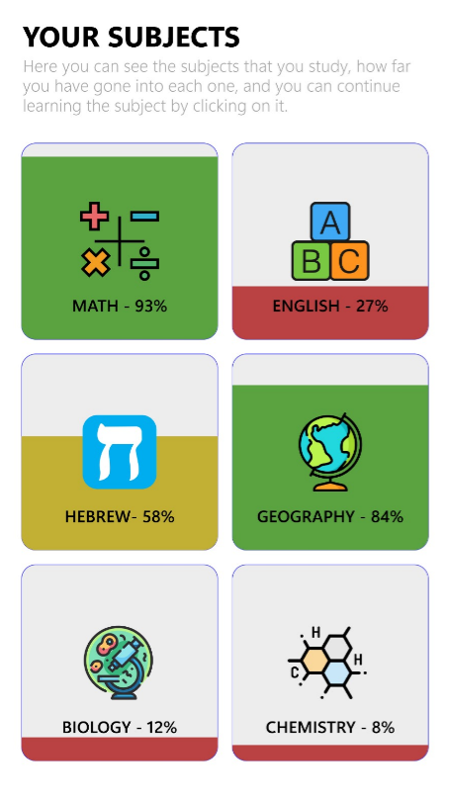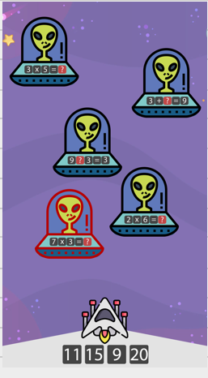

**7. Verification and Evaluation**

The GradeUp platform will be evaluated from both student and teacher perspectives to ensure it delivers a user-friendly, efficient, and adaptive environment for learning and teaching.

*7.1 Evaluation*

The evaluation criteria focus on:

* **Usability**: How easily users (students and teachers) can navigate the platform and complete their tasks.
* **Performance**: The system’s responsiveness, including page load times, assignment submission speed, and grade processing.
* **Scalability**: How well the platform handles increasing numbers of users.
* **Engagement**: Frequency and duration of student interactions with assignments, games, and discussions.
* **Adaptability**: Flexibility in managing different educational needs, including emergency situations and various learning styles.
* **Functionality**: Ensuring that teachers can manage classes, provide feedback, and track student progress efficiently.

*7.2 Verification*

The verification process ensures that both student and teacher components of the GradeUp platform function as intended.

Student Workflow (Verification)

1. **Login Process**:
   * Verify that students can log in securely and access personalized content.
2. **View Educational Materials**:
   * Test that students can easily view learning materials assigned to them (videos, quizzes, reading materials).
3. **Complete Assignments**:
   * Verify that students can complete and submit assignments, with real-time feedback on their progress.
4. **Engage with Gamified Elements**:
   * Confirm that students can engage with gamification features such as badges and rewards for completing tasks.
5. **View Grades and Feedback**:
   * Ensure students can view their grades and feedback after submitting assignments, with timely notifications.

Teacher Workflow (Verification)

1. **Login Process**:
   * Verify that teachers can log in securely and access their dashboard with relevant student and class data.
2. **View Subjects and Class Management**:
   * Test that teachers can view subjects they teach and manage class rosters.
3. **Send Assignments**:
   * Verify that teachers can create and send assignments, and choose different formats (text, multimedia, quizzes).
4. **View Student Submissions**:
   * Confirm that teachers can view and grade assignments submitted by students without errors.
5. **Provide Feedback and Grades**:
   * Test that teachers can provide feedback and assign grades, which are delivered to students in real-time.
6. **Track Student Progress**:
   * Verify that teachers can monitor student progress and access performance data for intervention when necessary.
7. **Communication with Students**:
   * Confirm that teachers can send messages or announcements and engage in discussions with students via chat or forums.

|  |  |  |  |
| --- | --- | --- | --- |
| Test | Module | Tested Function | Expected Result |
| 1 | User Interface | |  | | --- | | Student/Teacher Login |  |  | | --- | |  | | Pages load within 2 seconds. |
| 2 | |  | | --- | | Class Management |  |  | | --- | |  | | View Subjects and Students (Teacher) | Teachers view class rosters and subject materials easily. |
| 3 | Assignment Management | |  | | --- | | Send Assignment (Teacher) |  |  | | --- | |  | | Teachers create and send assignments to students smoothly. |
| 4 | |  | | --- | | Assignment Handling |  |  | | --- | |  | | |  | | --- | | Submit Assignment (Student) |  |  | | --- | |  | | |  | | --- | | Students submit assignments. |  |  | | --- | |  | |
| 5 | |  | | --- | | Feedback and Grades |  |  | | --- | |  | | |  | | --- | | Provide Feedback/Receive Feedback |  |  | | --- | |  | | |  | | --- | | Teachers provide and students receive feedback promptly. |  |  | | --- | |  | |
| 6 | |  | | --- | | Gamification |  |  | | --- | |  | | |  | | --- | | Engage with Games (Student) |  |  | | --- | |  | | |  | | --- | | Students participate in gamification elements (badges). |  |  | | --- | |  | |
| 7 | Emergency Management | Emergency Notification | Emergency alerts are sent and logged correctly |
| 8 | |  | | --- | | Progress Tracking |  |  | | --- | |  | | |  | | --- | | Track Progress (Teacher/Student) |  |  | | --- | |  | | |  | | --- | | Accurate progress data displayed for students/teachers. |  |  | | --- | |  | |
| 9 | |  | | --- | | Communication Tools |  |  | | --- | |  | | |  | | --- | | Forum/Discussion |  |  | | --- | |  | | |  | | --- | | Teachers and students communicate smoothly via platform. |  |  | | --- | |  | |
| 10 | |  | | --- | | Performance |  |  | | --- | |  | | |  | | --- | | System Load Handling |  |  | | --- | |  | | System handles up to X users without slowdowns. |

By integrating both student and teacher workflows, this comprehensive evaluation and verification plan ensures that all components of the GradeUp platform work effectively, creating a seamless and engaging learning environment for all users.

**References(APA):**

1. Hattie, J. (2008). *Visible learning: A synthesis of over 800 meta-analyses relating to achievement*. routledge.
2. DuPaul, G. J., Weyandt, L. L., & Janusis, G. M. (2011). ADHD in the classroom: Effective intervention strategies. *Theory into practice*, *50*(1), 35-42.
3. Reuge, N., Jenkins, R., Brossard, M., Soobrayan, B., Mizunoya, S., Ackers, J., ... & Taulo, W. G. (2021). Education response to COVID 19 pandemic, a special issue proposed by UNICEF: Editorial review. *International Journal of Educational Development*, *87*, 102485.
4. Schunk, D. H. (2012). *Learning theories an educational perspective*. Pearson Education, Inc.
5. Clark, R. C., & Mayer, R. E. (2023). *E-learning and the science of instruction: Proven guidelines for consumers and designers of multimedia learning*. john Wiley & sons.
6. Kearsley, G., & Shneiderman, B. (1998). Engagement theory: A framework for technology-based teaching and learning. *Educational technology*, *38*(5), 20-23.
7. Moore, M. G., & Kearsley, G. (2012). Distance education: A systems view of online learning.
8. Sarsa, H. (2013). *Does Gamification Work? A Literature Review* (Bachelor's thesis).
9. Anderson, T., & Dron, J. (2011). Three generations of distance education pedagogy. *International Review of Research in Open and Distributed Learning*, *12*(3), 80-97.
10. Karabenick, S. A., & Knapp, J. R. (1991). Relationship of academic help seeking to the use of learning strategies and other instrumental achievement behavior in college students. *Journal of educational psychology*, *83*(2), 221.

### Marc, P. (2001). Digital natives, digital immigrants. *On the horizon*, *9*(5), 1-6.

### Phillips, H. (2010). Multiple intelligences: Theory and application. *Perspectives In Learning*, *11*(1), 4.

### Reimers, F., Schleicher, A., Saavedra, J., & Tuominen, S. (2020). Supporting the continuation of teaching and learning during the COVID-19 Pandemic. *Oecd*, *1*(1), 1-38.

### Barkley, R. A. (Ed.). (2014). *Attention-deficit hyperactivity disorder: A handbook for diagnosis and treatment*. Guilford Publications.

### Murphy, R., Gallagher, L., Krumm, A. E., Mislevy, J., & Hafter, A. (2014). Research on the use of Khan Academy in schools: Research brief. *Menlo Park, CA., SRI International. Recuperado de https://www. sri. com/sites/default/files/publications/2014-03-07_implementation_briefing. pdf*.

### Watini, S., Aini, Q., Rahardja, U., Santoso, N. P. L., & Apriliasari, D. (2022). Class dojolms in the interactive learning of paud educators in the disruption era 4.0. *Journal of Innovation in Educational and Cultural Research*, *3*(2), 215-225.

### Fauzi, A., Wandira, R., Sepri, D., & Hafid, A. (2021). Exploring Students' Acceptance of Google Classroom during the COVID-19 Pandemic by Using the Technology Acceptance Model in West Sumatera Universities. *Electronic Journal of e-Learning*, *19*(4), 233-240.

### Ulfa, S. M., Susanto, S., & Purwati, O. (2022). The Impact of Online Platform Edmodo to Enhance Students' Motivation in Learning Writing at Tertiary Education. *World Journal on Educational Technology: Current Issues*, *14*(3), 704-713.

### Koomar, S., Coflan, C. M., & Kaye, T. (2020). Using EdTech in Settings of Fragility, Conflict and Violence: A Curated Resource List​(EdTech Hub Helpdesk Response No 8). DOI: 10.5281/zenodo. 3785138. Available under Creative Commons Attribution 4.0 International.

### Kurnava, S., & Sellhorn, J. (2018). The effect of Seesaw technology on parent engagement at private Montessori schools.

### Bul, K. C., Franken, I. H., Van der Oord, S., Kato, P. M., Danckaerts, M., Vreeke, L. J., ... & Maras, A. (2015). Development and user satisfaction of “Plan-It Commander,” a serious game for children with ADHD. *Games for health journal*, *4*(6), 502-512.

### Prompts Used (ChatGPT):

### "Expand the introduction to include more detail about how the GradeUp platform addresses the challenges faced during emergency situations."

### "Write a background section focusing on how emergency situations like wars and pandemics disrupt traditional classroom education."

### "Rewrite the related work section to focus more on how technology has been used in emergency education, with less emphasis on ADHD."

### "Enhance the expected achievements section by adding specific measurable outcomes for the GradeUp platform."

### "I want the requirements too, the functional and Non-functional."

### "I want current challenges faced by traditional classroom education with references."

### "I want to do a use case that includes student, teacher with the system as GradeUp, Give me some ideas"

### "I want to simplify the explanation of the sequence diagram and ensure it aligns with the provided use case."

### "Provide an overview of how cloud technology is being used in modern educational platforms with references to check"

### "Write a brief description of how GradeUp will incorporate real-time progress tracking for students."

### "Enhance the language of this text : ………. "